 

**Loyola INSTITUTE OF TECHNOLOGY & SCIENCE**

**LOYOLA NAGAR, THOVALAI – RAJAVOOR ROAD, KANYAKUMARI – 629302**

**Approved by AICTE, New Delhi and Affiliated to Anna University.**

DEPARTMENT OF INFORMATION TECHNOLOGY

Completed the Project named as

**Military Soldier Safety System**

*Submitted by,*

**M. PETER TOPSON-(961222205303)**

**INTRODUCTION:**

Modern warfare and combat missions demand high levels of safety, situational awareness, and real-time monitoring for soldiers. With the help of advanced technologies, it's possible to ensure real-time health tracking, position monitoring, and environmental threat detection to enhance soldier safety. This project proposes a system to support soldiers with better safety tools using sensors, GPS, and wireless communication technologies.

**ABSTRACT:**

This project presents a real-time military soldier safety system designed to monitor various aspects such as soldier health, location, and environmental threats. The system integrates GPS modules, health sensors (like heart rate and temperature sensors), and wireless communication to send live data to the control center. The data can be used for tracking, decision-making, and emergency responses. The solution aims to reduce the risks soldiers face during missions by providing commanders with actionable real-time data.

**OBJECTIVES:**

* To monitor the real-time location of soldiers using GPS.
* To measure and report vital health parameters like heart rate and body temperature.
* To send alerts in emergency or abnormal conditions (e.g., injury, fall, irregular heartbeat).
* To improve coordination and decision-making at the control center.
* To ensure safety and rapid response in combat situations.

**TOOLS AND TECHNOLOGIES:**

**Microcontroller:**

Arduino Uno / ESP32 / Raspberry Pi

**Sensors:**

Heartbeat sensor

Temperature sensor (LM35 or DHT11)

Motion/Fall sensor (Accelerometer)

**GPS Module:**

Neo-6M or similar

**Wireless Communication:**

GSM/GPRS Module (SIM800L), LoRa, or Wi-Fi

**Programming Language:**

Embedded C / Python

**Software:**

Arduino IDE / Python IDE / Blynk / MIT App Inventor (for mobile apps)

**IMPLEMENTATION:**

* Real-time soldier monitoring via camera feed
* Detection of falls or unconscious states using posture detection (with Mediapipe)
* Alert triggering when a fall or inactivity is detected

import cv2

import mediapipe as mp

import time

# Initialize Mediapipe pose estimator

mp_pose = mp.solutions.pose

pose = mp_pose.Pose()

mp_draw = mp.solutions.drawing_utils

# Initialize camera

cap = cv2.VideoCapture(0)

# Inactivity detection

last_movement_time = time.time()

fall_detected = False

def is_fallen(landmarks):

# Check the angle of torso for fall detection (simple example)

left_shoulder = landmarks[mp_pose.PoseLandmark.LEFT_SHOULDER.value]

left_hip = landmarks[mp_pose.PoseLandmark.LEFT_HIP.value]

dx = abs(left_shoulder.x - left_hip.x)

dy = abs(left_shoulder.y - left_hip.y)

# If vertical distance is small, assume lying down

return dy < dx

while True:

success, frame = cap.read()

if not success:

break

# Flip and convert image

frame = cv2.flip(frame, 1)

img_rgb = cv2.cvtColor(frame, cv2.COLOR_BGR2RGB)

results = pose.process(img_rgb)

if results.pose_landmarks:

mp_draw.draw_landmarks(frame, results.pose_landmarks, mp_pose.POSE_CONNECTIONS)

landmarks = results.pose_landmarks.landmark

if is_fallen(landmarks):

cv2.putText(frame, "⚠️ Fall Detected!", (50, 50),

cv2.FONT_HERSHEY_SIMPLEX, 1, (0, 0, 255), 3)

fall_detected = True

else:

fall_detected = False

last_movement_time = time.time()

# Inactivity alert (no movement for 10 seconds)

if time.time() - last_movement_time > 10:

cv2.putText(frame, "⏱️ Inactivity Detected!", (50, 100),

cv2.FONT_HERSHEY_SIMPLEX, 1, (0, 165, 255), 3)

# Display frame

cv2.imshow("Soldier Monitoring", frame)

if cv2.waitKey(1) & 0xFF == ord('q'):

break

cap.release()

cv2.destroyAllWindows()

**REAL-TIME DETECTION SNAPSHOT:**

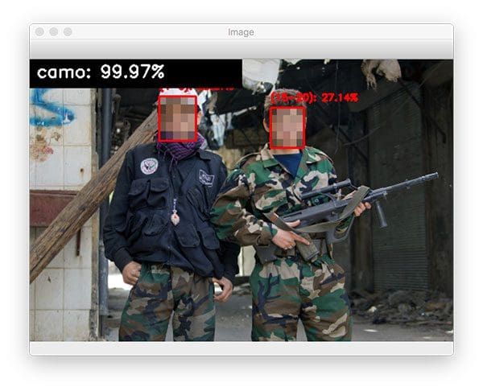

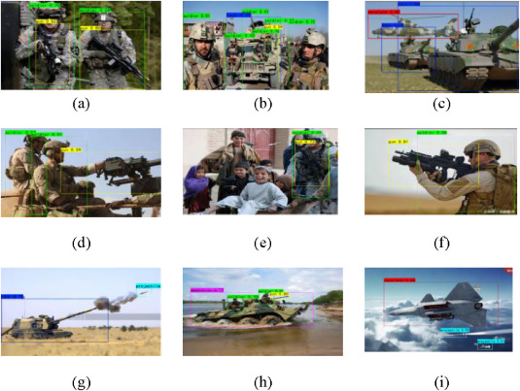

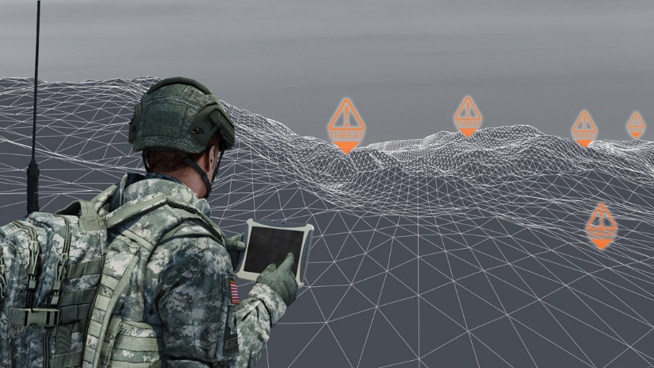

**OUTPUT REVIEW:**

* Real-time display of soldier's location on a map.
* Health parameters updated every few seconds.
* Automated alert messages to base station in emergencies.
* Log records for mission playback or review.

**✅ ADVANTAGES OF MILITARY SOLDIER SAFETY SYSTEM:**

1. **Real-time Monitoring:** Continuous tracking of soldier’s health and location.
2. **Improved Emergency Response:** Instant alerts help commanders act quickly in case of injury or abnormal conditions.
3. **Enhanced Operational Coordination:** Command centers get situational awareness during missions.
4. **Life-Saving Capabilities:** Early detection of issues (like high temperature or irregular heartbeat) increases survival chances.
5. **Data Logging:** Useful for post-mission analysis and training.
6. **Remote Accessibility:** Data can be accessed from remote locations over GSM or Wi-Fi.

**⚠️ DISADVANTAGES OF MILITARY SOLDIER SAFETY SYSTEM:**

1. **Dependence on Network:** Functionality is limited in areas with poor signal.
2. **Battery Constraints:** Wearable devices require frequent charging or power management.
3. **Sensor Limitations:** Accuracy may be affected in harsh environmental conditions.
4. **Cost:** Implementation and maintenance can be expensive.
5. **Security Risks:** Wireless data can be intercepted if not properly encrypted.

**🎯 APPLICATIONS OF MILITARY SOLDIER SAFETY SYSTEM:**

* Border surveillance and combat zones.
* Rescue operations in disaster-hit areas.
* Military training exercises.
* Search and recovery missions.
* Anti-terrorist and special task force operations.

**🌟 KEY FEATURES:**

* GPS-based real-time location tracking.
* Health monitoring sensors (heart rate, temperature, etc.).
* Emergency alert system.
* Wireless communication (GSM/Wi-Fi/LoRa).
* Fall/inactivity detection.
* Centralized monitoring dashboard or mobile app.

**🪖 SCENARIOS:**

* A soldier is wounded and becomes immobile — the system detects no motion and sends an alert.
* A patrol unit is separated — commanders can locate every soldier on the map instantly.
* A sudden spike in temperature or irregular heart rate is detected — medical team is notified in advance.

**🎯 KEY OBJECTIVES:**

1. Ensure real-time health and location monitoring of soldiers.
2. Provide immediate alerts during critical or life-threatening situations.
3. Improve mission coordination and reduce response time.
4. Increase overall safety and survivability of military personnel.
5. Create a reliable communication link between soldiers and command centers.

**CONCLUSION:**

This Military Soldier Safety System is a comprehensive solution aimed at protecting frontline soldiers through the use of advanced tracking and monitoring technologies. With real-time data access, base stations can respond faster to emergencies, monitor health, and ensure operational success. Future improvements may include AI-based prediction systems, wearable smart helmets, and integration with drones for extended surveillance.